The Wholesale Russet Potato Pricing Playbook: How to Get the Best Rates

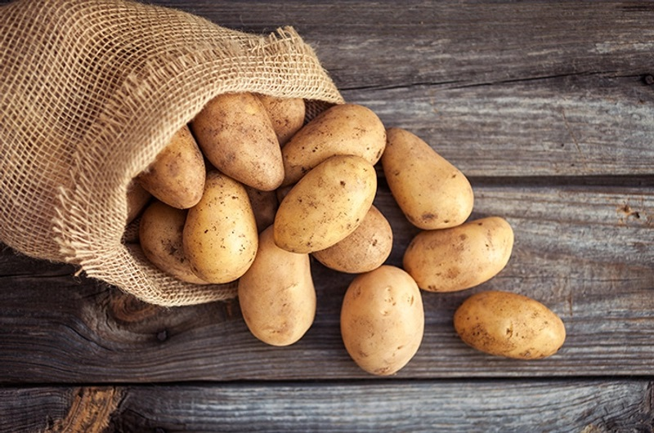

Chestnut potatoes are a staple element for innumerable food organizations, including eateries, supermarkets, and food producers. Their adaptability, rich surface, and high starch content make them ideal for broiling, crushing, and baking. Be that as it may, obtaining excellent reddish brown potatoes at the best discount costs requires industry information, key preparation, and the right provider organizations.

In this aide, we uncover the key to getting the[Russet Potatoes](https://netherlandspotatosuppliers.com/) freshest chestnut potatoes at superb mass costs while guaranteeing top-level quality and steady stockpile.

Grasping Chestnut Potato Quality Norms

1. Evaluating and Characterization

Discount chestnut potatoes are evaluated in view of their size, shape, and by and large condition. The most well-known groupings include:

U.S. No. 1 - Premium-quality potatoes with uniform size, insignificant flaws, and ideal for retail and top of the line eatery use.

U.S. No. 2 - Marginally lower in grade, with minor defects yet at the same time appropriate for handling and enormous scope food creation.

Handling Grade - Involved basically by food producers for making potato chips, fries, and other handled potato items.

2. Key Quality Markers

To guarantee you're obtaining hands down the best chestnut potatoes, focus on:

Skin Surface - Smooth, firm, and liberated from exorbitant imperfections or breaks.

Size Consistency - Uniform sizes make taking care of and cooking more straightforward.

Dampness Content - Ought to be dry to the touch, as exorbitant dampness can show early decay.

Growing and Swelling - Keep away from providers that convey potatoes with noticeable growing or profound swelling.

Best Places to Source Discount Reddish brown Potatoes

1. Direct Ranch Organizations

One of the most amazing ways of getting great chestnut potatoes at discount costs is to buy straightforwardly from ranches. This approach offers:

Fresher Produce - Homestead direct potatoes are frequently reaped and sent in practically no time, guaranteeing top newness.

Lower Expenses - Reducing out brokers decreases markup expenses, prompting better valuing.

Predictable Stock - Laying out long haul contracts with ranches ensures a consistent progression of potatoes over time.

Top chestnut potato-creating states include:

Idaho - Eminent for its prevalent reddish brown potatoes, with ranches like Wada Homesteads and Sun-Glo of Idaho offering discount supply.

Washington - Home to top notch potato ranches with astounding developing circumstances.

Wisconsin - A key part in the U.S. potato industry, known for supportable cultivating rehearses.

2. Discount Produce Markets

Significant urban communities have huge produce markets where organizations can source mass chestnut potatoes. These business sectors give serious estimating and admittance to various providers. A portion of the top discount produce markets include:

Chases Point Produce Market (New York, NY) - One of the biggest discount markets in the U.S.

Chicago Worldwide Produce Market (Chicago, IL) - A critical center point for Midwest-based purchasers.

Los Angeles Discount Produce Market (Los Angeles, CA) - A superb objective for mass produce obtaining on the West Coast.

3. Foodservice Merchants

Public foodservice wholesalers offer dependable mass stockpile with conveyance choices for organizations, all things considered. Driving organizations include:

Sysco - One of the biggest food conveyance organizations in the U.S., giving steady quality and cross country transporting.

US Food varieties - Works in foodservice supply, taking special care of eateries, schools, and medical services offices.

Gordon Food Administration (GFS) - A confided in hotspot for discount chestnut potatoes with adaptable buying choices.

4. Online Mass Providers

Web based business stages have made it more straightforward than at any other time to source discount chestnut potatoes on the web. Probably the best internet based choices include:

WebstaurantStore - Ideal for cafés and foodservice organizations searching for quick transportation.

Produce Coalition - Furnishes adaptable mass requests with ranch direct obtaining.

Amazon Business - Offers an assortment of discount potato providers with mass buying choices.

Step by step instructions to Arrange the Best Discount Costs

1. Purchase in Mass

Bigger orders ordinarily accompany volume limits. Consider requesting in load amounts to augment reserve funds.

2. Lay out Long haul Agreements

Providers frequently give better valuing to organizations able to focus on continuous buys. Secure a drawn out concurrence with solid providers to secure in positive rates.

3. Influence Occasional Value Drops

Potato costs change in light of irregularity. The best opportunity to purchase is following harvest when supply is most elevated, regularly in pre-fall and late-summer.

4. Look at Numerous Providers

Demand statements from somewhere around three distinct providers to guarantee you're getting the best arrangement. Think about both cost and quality while going with a last choice.

Capacity Tips for Mass Chestnut Potatoes

1. Keep up with Appropriate Temperature

Store reddish brown potatoes in a cool, dull climate with temperatures somewhere in the range of 45°F and 50°F. This forestalls growing and keeps up with newness.

2. Guarantee Great Ventilation

Potatoes need satisfactory wind stream to forestall dampness development, which can prompt decay. Keep away from sealed shut holders and pick ventilated capacity canisters.

3. Screen Mugginess Levels

Stickiness ought to be kept around 90% to 95% to forestall lack of hydration while keeping away from overabundance dampness that can cause decay.

4. Use FIFO (Earliest in, earliest out) Stock Administration

Continuously turn stock to utilize more seasoned potatoes first, forestalling waste and guaranteeing item newness.

Normal Mix-ups to Stay away from While Purchasing Discount Chestnut Potatoes

1. Disregarding Quality Over Cost

While getting a low cost is fundamental, thinking twice about quality can prompt waste and client disappointment. Continuously examine tests prior to resolving to mass buys.

2. Sitting above Transportation Expenses

Cargo expenses can altogether influence the general cost of discount potatoes. Work with providers that offer serious transportation rates or neighborhood pickup choices.

3. Purchasing Beyond what You Can Store

Ill-advised capacity prompts squandered stock. Just buy what your business can store and utilize effectively.

4. Not Checking Providers Appropriately

Guarantee providers have industry affirmations, like USDA endorsement and HACCP consistence, to ensure sanitation and quality.

End

Obtaining great chestnut potatoes at discount costs requires an essential methodology. By working straightforwardly with ranches, utilizing discount produce showcases, and collaborating with legitimate foodservice merchants, organizations can get the best arrangements while guaranteeing top-level quality.

By carrying out brilliant exchange strategies, legitimate capacity techniques, and provider screening, you can keep a consistent stockpile of premium reddish brown potatoes while expanding cost investment funds. Whether you're an eatery proprietor, supermarket chief, or food maker, these bits of knowledge will assist you with smoothing out your obtainment cycle and remain serious on the lookout.